

**FPT ACADEMY INTERNATIONAL**

**FPT – APTECH COMPUTER EDUCATION**

**Vinegar Food Restaurant**

**WEBSITE**

|  |  |  |  |
| --- | --- | --- | --- |
| **Center Name** | | ACE-HCMC-2-FPT  Address: 590 Cach Mang Thang Tam, District 3, Ho Chi Minh City | |
| **Instructor** | | Mr. Nguyen Van Binh | |
| **Class** | | T1.2005.E3 | |
| **Group** | | 1 | |
| **Group members** | | **Name** | **Student ID** |
| Hoang Huu Nghia | Student1268270 |
| Nguyen Thien Quan | Student1267396 |
| Vu Ba Thai An | Student1267392 |
| **Duration** | **Start date** | 1st Aug 2020 | |
| **End date** | 1st Sep 2020 | |

**This is to certify that**

**Mr./Ms.:**

Hoang Huu Nghia

Nguyen Thien Quan

Vu Ba Thai An

**has successfully designed & developed**

eProject: Vinegar Food Restaurant website

**Submitted by:**

Hoang Huu Nghia

**Date of issue:**

**Authorized Signature:**

**TABLE OF CONTENTS**

ACKNOWLEDGEMENT 4

SYNOPSIS 4

PROBLEM STATEMENT 5

CUSTOMER'S REQUIREMENTS SPECIFICATIONS 6

SCOPE OF THE WORK (IN BRIEF) 7

# ACKNOWLEDGEMENT

Teaching is a noble profession, with the responsibility of imparting knowledge and experience to students. We have spent more than 2 months studying at FPT Aptech and we would like to take this opportunity to thank our teacher Mr. Nguyen Van Binh, the teacher has accompanied and instructed during the past time.

Thank you also to Aptech India for giving us the opportunity to implement this eProject, so that we can apply what we have learned in practice and gain practical experience.

# SYNOPSIS

Vinegar Food Restaurant which is the flagship brand of JADONS Ltd (Limited Liability Company) has spread over its aroma in this industry over the past few decades. Known as “the Serving plates” with 72 different rotating menus and 240000 delicacies throughout the country.

Vinegar Food Restaurant came to Vietnam and wanted to create a website to highlight elements such as:

* There is banquet service in the restaurant with luxurious rooms for group party parties, cozy for family parties, and a large lobby for wedding or company parties.
* Includes Vietnamese Chinese Western dishes
* And the slogan:
  + A perfect meal! That's the Vinegar Food Restaurant

# PROBLEM STATEMENT

After reading the requirements from Jadons Ltd, our group has discussed about what should to be done to fulfill them properly. We came to conclusion that in order to achieve the best result, we should deal with following queries:

1. How many tabs should be displayed?

* About 14 pages (can adjust) :
  + Home; About us + Awards; Gallery + Recipe of the month; Catering; Contact us + Feed back; Meals/Menus (Regular, Lunch, Snacks, Desert, Beverages).

1. How is each web page designed to offer users the enjoyable experience?

* The main color of the background is simple color to emphasize the aroma of dish.
* Each page will have the same header and footer bar so the page turns smoothly without dizzying users.
* Using javascipt when scrolling the page, and hover of css to create interest for users.
* The page will probably have a call button using AJAX.

1. Who are web users interact with the website?

* The users are people who are well-off. The website has to be both eye-catching and easily, quickly manipulated for them.
* The hot dishes are displayed on slide panel of HomePage and users can click

1. What browsers can the website be run on?

* The website will be built to run efficiently only on Windows platform. However, it still can be compatible on all leading web browsers such as Chrome, IE and Firefox.

# 

# CUSTOMER'S REQUIREMENTS SPECIFICATIONS

1. **Client:** Vinegar Food Restaurant website
2. **Input to the system:**

* **From webmaster:**
* Information about Vinegar Food Restaurant
* Dishes of restaurant
* Contact details
* **From web users:**
* Searching for contacts including address, email, phone numbers
* Referring dishes
* **Output from the system:**
* Form for user to feed back
* Images and recipe of dishes
* Images and information of catering

1. **Hardware/ Software Requirements**

* **For webmaster**

**Hardware**

* Intel Pentium 4 processor or higher
* 1 Gigabytes of RAM or higher

**Software**

* Windows 7 OS or higher
* Visual Studio Code and Webstorm
* HTML5 and Javascript supporting web browsers such as IE, Chrome or Firefox
* **For web users**

**Hardware**

* Intel Pentium 4 processor or higher
* 512 Megabytes of RAM or higher

**Software**

* Windows XP OS or higher
* HTML5 and Javascript supporting web browsers such as IE, Chrome or Firefox

# SCOPE OF THE WORK (IN BRIEF)

After a long and detailed discussion, our group has decided to create a website contain the following webpages:

1. ***Homepage***: Display general information about Vinegar Food Restaurant with best sale dishes pictures in order to attract users in the best way.
2. **About us:** Information details including awards, slogan,…
3. **Gallery + Recipe of month:** A lot of images dishes and recipe
4. **Contact us + Feedback:** Display address, Geolocation, Feed back for users
5. **Catering:** Information about inside party services (wedding party, seminar, event party); images about room for catering
6. **Meals:** Includes 5 subpages (regular, lunch, snacks, desert, beverages)

**TASK SHEET REVIEW 1**

|  |  |  |  |  |  |  |  |
| --- | --- | --- | --- | --- | --- | --- | --- |
| **Project Ref. No.:**  **eP/Advertisement** **Portal Management** **System/01** | | **Project Title:** | **Activity Plan** **Prepared** **By:** | **Date of Preparation of Activity Plan:** | | | |
| **Sr.No.** | **Task** | **Actual Start** **Date** | **Actual** **Days** | **Team** **Mate** **Names** | **Status** |
| 1 | Problem Statement | Vinegar Food Restaurant | Nghia + Quan + An | 1st Aug | 3 | Nghia | Finish |
| 2 | Analysis of Vinegar Food Restaurant requirements about the website | 1st Aug | 3 | Quan | Finish |
| 3 | The scope of the work (in brief) | 1st Aug | 3 | An | Finish |
| 4 | Task Sheet | 1st Aug | 4 | Nghia | Finish |

|  |  |
| --- | --- |
| Date: | |
| Signature of Instructor  **Mr. Nguyen Van Binh** | Signature of Team Leader  **Hoang Huu Nghia** |

# SITE MAP

# MOCK OF THE WEBSITE

We divide the website structure into layouts which will be displayed below. The header section includes Vinegar Food Restaurant logo and the Navigation Bar. Some tabs will have the pictures slideshow with the nice animation. The main content of each tab will be displayed in “Content” section. The footer includes Phone, Online Time, Email, Map.

## Home page

|  |
| --- |
| Content  **CATERING**  **HEADER**  **(LOGO – NAVIGATION BAR)**  **PICTURE SLIDESHOW**  **RECIPE**  **AWARDS**  **GALLERY**  Recipe food  Recipe food  Recipe food  Recipe food  Recipe food  Picture  Picture  Picture  Picture  Picture |

1. **Home page (continue)**

|  |
| --- |
| **FOOTER**  **About team Development** |

1. **Meals (Regular, Lunch, Dessert, Beverages)**

|  |
| --- |
| picture for Beverages  picture for Dessert  picture for Lunch  picture for regular  Beverages  Dessert  Lunch  Regular  **FOOTER**  **HEADER**  **(LOGO – NAVIGATION BAR)** |

**TASK SHEET REVIEW 2**

|  |  |  |  |  |  |  |  |
| --- | --- | --- | --- | --- | --- | --- | --- |
| **Project Ref. No.:**  **eP/Advertisement** **Portal Management** **System/01** | | **Project Title:** | **Activity Plan** **Prepared** **By:** | **Date of Preparation of Activity Plan:** | | | |
| **Sr.No.** | **Task** | **Actual Start** **Date** | **Actual** **Days** | **Team** **Mate** **Names** | **Status** |
| 1 | Site map | Vinegar Food Restaurant | Nghia | 9/8/20 | 1 | Nghia | Completed |
| 2 | Mock of the website | 9/7/20 | 2 | all | Completed |
| 3 | Task sheet | 9/8/20 | 1 | Nghia | Completed |

|  |  |
| --- | --- |
| **Date:** | |
| Signature of Instructor:  **Mr. Ngo Phuoc Nguyen** | Signature of Team Leader:  **Hoang Huu Nghia** |

# WEBSITE DESCRIPTION

## Home page

1. *Description*

*We provide a slider shows food and room pictures in the restaurant.*

1. *Snapshot*

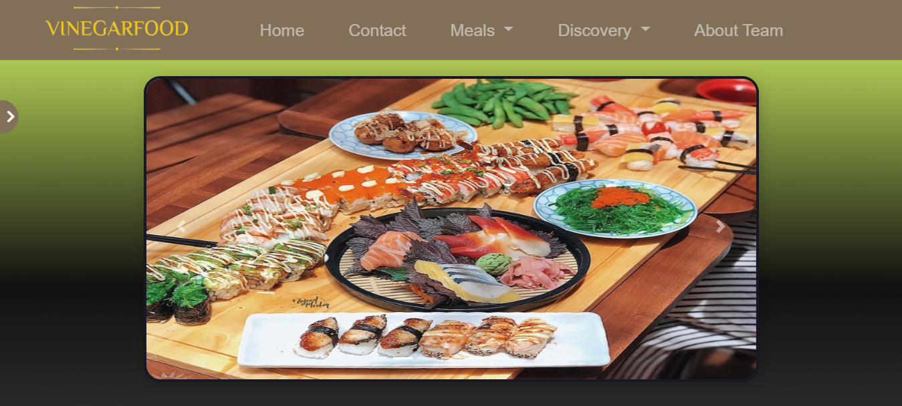

## Awards

1. *Description*

*The awards section provides information and received awards of Vinegar Food Restaurant.*

1. *Snapshot*

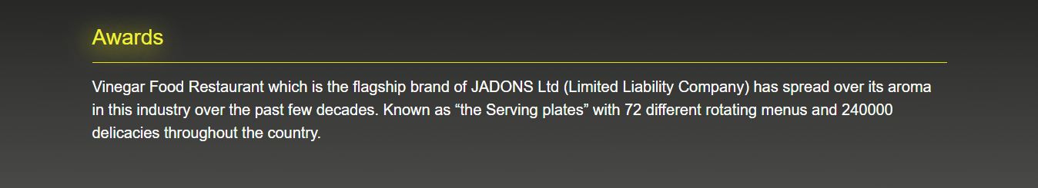

## Gallery

1. *Description*

*This section provides pictures and names of food.*

1. *Snapshot*

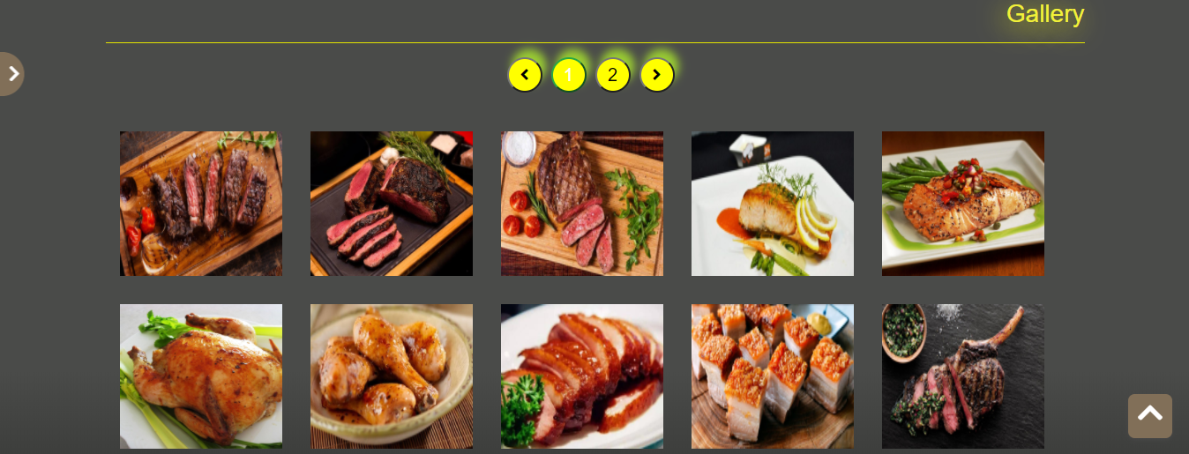

## Recipe

1. *Description*

*This section provides recipe of food every month.*

1. *Snapshot*

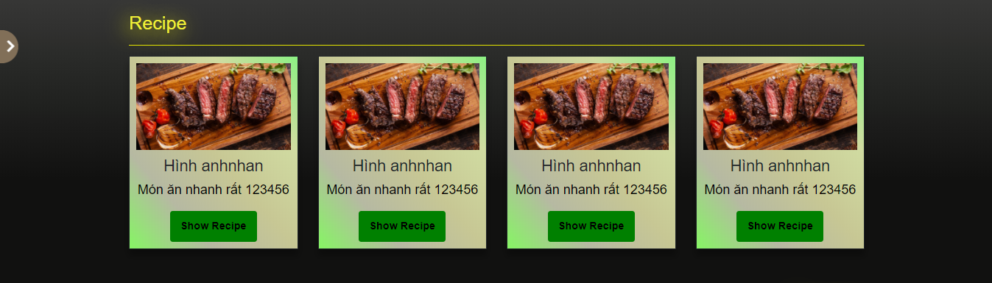

## Catering

1. *Description*

*This section provides inside and outside catering, books catering..*

1. *Snapshot*

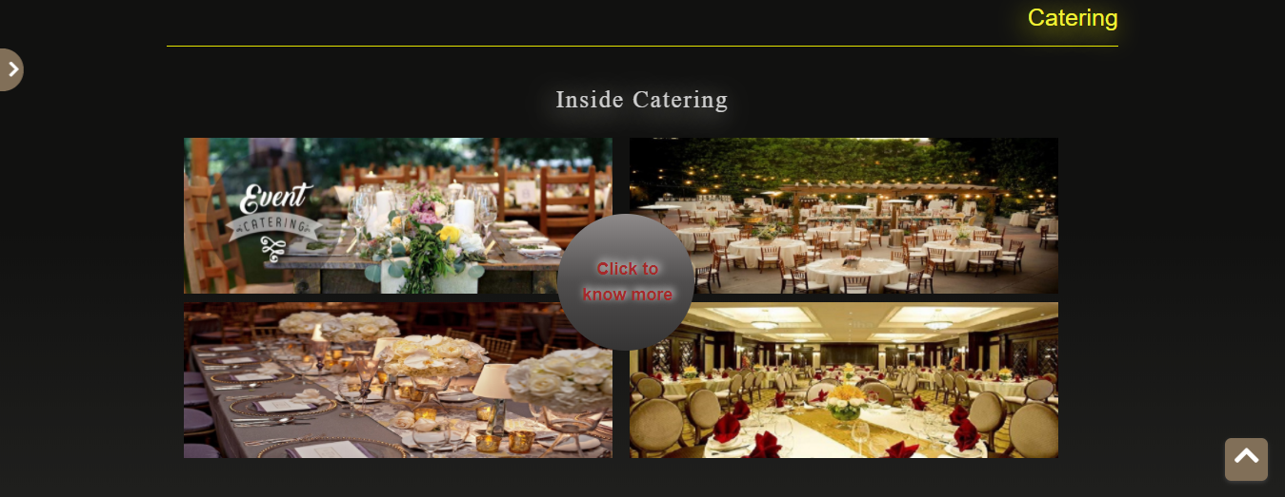

## About team development

1. *Description*

*This section provides inside and outside catering, books catering..*

1. *Snapshot*

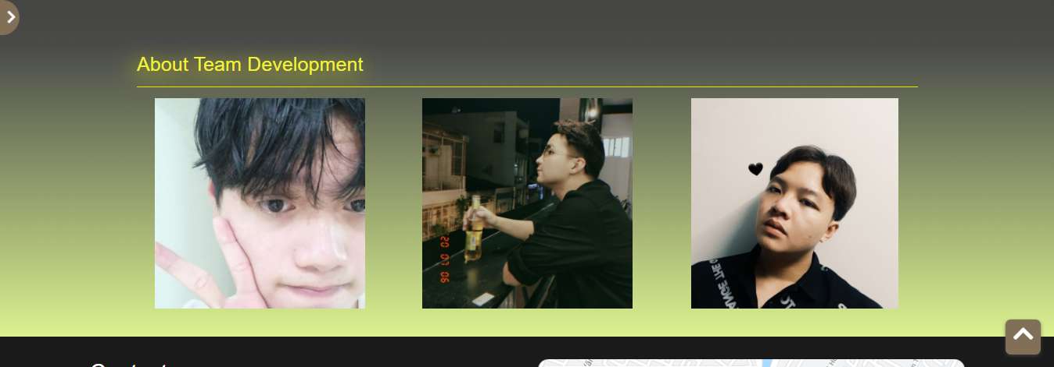

## Contact

1. *Description*

*This section provides inside and outside catering, books catering..*

1. *Snapshot*

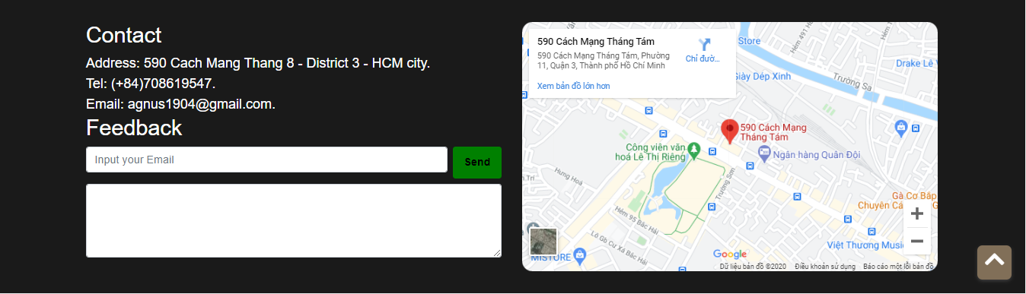

**TASK SHEET REVIEW 3**

|  |  |  |  |  |  |  |  |
| --- | --- | --- | --- | --- | --- | --- | --- |
| **Project Ref. No:**  **eP/Advertisement Portal Managament System/01** | | **Project Title:** | **Activity Plan Prepared by:** | **Date of Preparation of activity plan** | | | |
| **Sr. No.** | **Task** |  |  | **Actual start date** | **Actual days** | **Teammate name** | **Status** |
| 1 | Homepage | Vinegar Food Restaurant | Nghia | 15/8/2020 |  | Nghia |  |
| 2 | Awards | 15/8/2020 |  | Nghia |  |
| 3 | Recipe | 15/8/2020 |  | Quan Nghia |  |
| 4 | Gallery | 15/8/2020 |  | Quan Nghia |  |
| 5 | Catering | 15/8/2020 |  | An  Nghia |  |
| 6 | Contact | 15/8/2020 |  | Nghia |  |
| 7 | Meals | 15/8/2020 |  | All |  |
| 8 | About team | 15/8/2020 |  | Nghia |  |